Tasks
Part 1: Log Type Mapping:
[1] Document all log types available on the ADS machine (not just Bazel)
A. Bazel logs : nx_dev

CI bazel logs:

'error.log.images^final^bazel^core_64_n9000'
'error.log.images^final^bazel^eth_64_n9000'
'error.log.images^final^bazel^linecardimages'
'error.log.images^final^bazel^nxos64'
'error.log.images^final^bazel^nxos64_msx'
'error.log.images^final^bazel^nxos64_noncs'
'error.log.images^final^bazel^nxos64_s1'
'error.log.images^final^bazel^nxos64_s1_dpu'
'error.log.images^final^nxos64_parallel'

CD Bazel Logs:

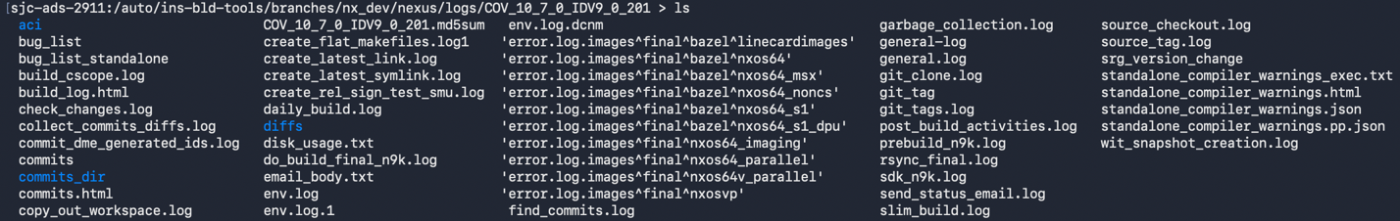

'error.log.images^final^nxos64_imaging'
'error.log.images^final^nxosvp'
'error.log.images^final^nxos64v_parallel'
'error.log.images^final^nxos64_parallel'
'error.log.images^final^bazel^nxos64_msx'
'error.log.images^final^bazel^nxos64_s1_dpu'
'error.log.images^final^bazel^nxos64_s1'
'error.log.images^final^bazel^nxos64_noncs'
'error.log.images^final^bazel^nxos64'
'error.log.images^final^bazel^linecardimages'
B. Gmake logs : nx_main
[2] Identify CI logs (developer builds triggered by PRs) vs CD logs (nightly production builds)

CI logs : developer PRs
CD logs: official nightly builds
<See question 1 to view log files>

[3] Determine if nightly build (CD) logs are accessible from the same NFS location or require separate access

Location to access logs:
- CD nightly build logs:
  - If Status=Success | Fail, available at <standalone path>/build/
  - If Status=Success, available at <standalone path>
    - Retained for 2 weeks
  - If Status=Fail, copied to (/auto/ins-bld-tools/branches/nx_dev/nexus/logs/)
    - Retained for 5 years
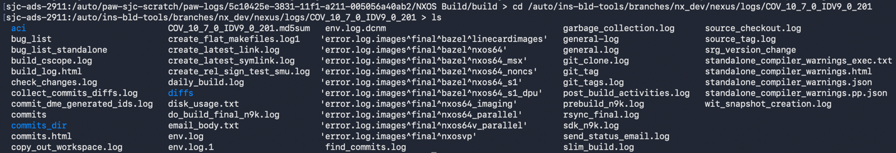

- CI developer PR build logs:
  - If Status=Success, logs at NFS path in PR. (eg. /auto/paw-sjc-scratch/paw-logs/5c10425e-3831-11f1-a211-005056a40ab2/NXOS\ Build/build/)
    - Deleted after PR merge
  - If Status=Fail, logs at NFS path in PR
    - Retained for 3-5 days

[4] Check whether log files are composite (multiple applications blended into one file) or individual per application/stage
1. Folder per build (COV_10_7_0_IDV9_0_201)
2. Logs per stage: linecard, nxos64, nxos64_msx, nxos64_noncs, nxos64_s1, nxos64_s1_dpu, nxos64_imaging, nxos64v_parallel, nxosvp
3. If CD builds, generates built_log.html. Has status of various checks.
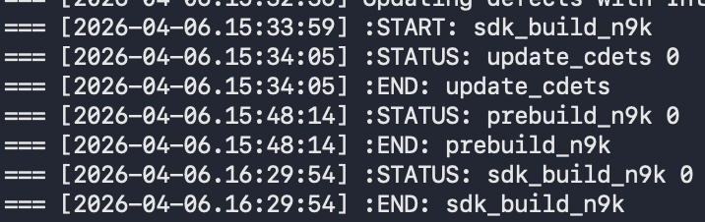
4. If CI builds, built_log.html not visible
[5] Document: within a single Bazel build, what are the 12-15 log files? Are they per-stage, per-module, or something else?
Per checks/stage
[6] Note the NFS path structure and how logs are organized (by date? by build number? flat directory?)
1. CD logs NFS structure:
log_dir = f"/auto/ins-bld-tools/branches/{branch}/nexus/logs/{tag}"
log_prefix = 'error.log.images^final^bazel'
eg: /auto/ins-bld-tools/branches/nx_dev/nexus/logs/COV_10_7_0_IDV9_0_201
- CI logs NFS structure:
eg: /auto/paw-sjc-scratch/paw-logs/5c10425e-3831-11f1-a211-005056a40ab2/NXOS Build/build

